**Recipedia**

**Team 36**

**Timothy To, Yiyi Zhang, Sean Zurcher**

**Project Description**

Our project will be an implementation of a recipe book for casual home use. It will allow users to interact with it in much the same way one would interact with a physical cookbook, mainly by looking up recipes that have been stored in a database. Users will be able to search for specific recipes by directly searching for names or by filtering them based on ingredients, preparation time, dish category (main, side, dessert, etc.), serving size and alphabetization.

Additionally, users can expand the cookbook by adding their own recipes to the database. Users should also be able to favorite recipes and have those appear on their own separate filter for themselves. Users should be able to rate recipes and on the front page the highest rated recipes should show up.

Stakeholders in our project include anyone who is interested in cooking. This project will function as an easy tool for home cooks to keep track of their existing recipes, find new ones, and reference them in the future. Our project will act as an entry point for home cooks to broaden their knowledge and to find new and exciting foods to explore.

**System Environment**

* A Structure Diagram of the system (graph/diagram based on 3-tier architecture)
  + Hardware: It should ideally be able to run on three separate machines and still all connect fine, but for the sake of the project we’ll be hosting it all on one computer.

Software: Any web browser should be able to access the front end. We’ll be using Apache/Tomcat for the server and MySQL for the database management system.

* + RDBMS used: MySQL: the standard query language for interacting with relational database.
  + Programming/Application languages used: React/Javascript (+HTML, CSS) for front end, Java for backend, SQL for RDBMS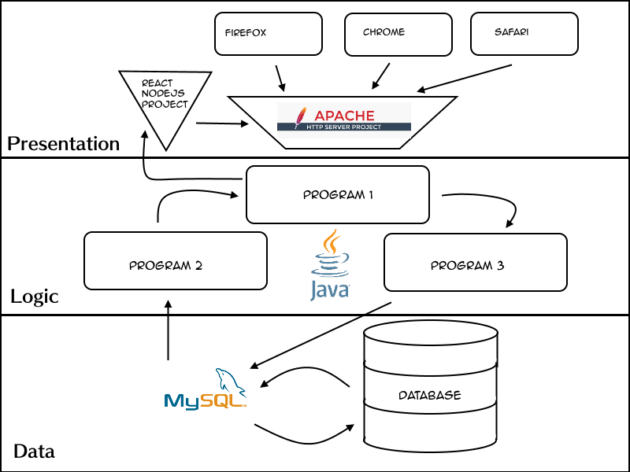

**Functional Requirements**

* Describe users and how users access the system.

Users will be able to search for recipes by different filters. According to users’ requirements, system will select the appropriate recipes from database, and list them on the web page. Also, users can create their own account through entering their personal information, such as name and email, to access the recipe book. By logging/logging out of their account, they can access more elaborated functionalities like saving their favorite recipes, creating/deleting their own specific recipes, and rating the recipes. These will also be recorded in the database.

* Describe each functionality/features, functional processes, and I/O(s).
* Register: Users need to register the system by entering their username, password, and email to access the recipe book. The information will be kept in the database.
* Login: The users who have registered need to login to access more performance.
* View Profile: After being successfully registered. Users can view their profile where information of username and email are displayed.
* Edit Profile: Users will be able to edit the profile they saved including their username and password.
* Search Recipe: Users will be able to search for a recipe by filtering them based on titles, ingredients, preparation time, dish category (main, side, dessert, etc.), serving size and alphabetization.
* Rate Recipe: Users can rate recipe according to their own tastes.
* View Recipe: Users will be able to see the recipes posted by other users and ordered by rate.
* Create Recipe: Users will be able to add their own specific recipes. The creation of recipe include entering title, ingredients, preparation time, category and description, steps and other information.
* Delete Recipe: Users can also the recipe they created.
* Add Favorite: Users can mark the recipes as their favorite.
* View My (Favorite) Recipe: Users will be able to view all recipes they created/marked as favorite.

**Nonfunctional Issues**

* GUI done in React using HTML and CSS.

The application will be easy to use, and has a user-friendly interface which is simple and clear. The interface contains clear navigation with buttons and plain view part helps users understand and find the recipe they want. Users will accomplish their goal easily and quickly with few or no user errors.

* Security

The system will be able to automatically log out all customers after a period of inactivity. Also, the system should not leave any cookies on the customer’s computer containing the user’s password. The system will be protected from any external danger or attacks.

* Access Control

Account access control can be done with cookie based authentication. The system’s back-end servers shall only be accessible to authenticated administrators.